Looking Ahead
Next Sunday’s Message: “The Choices We Make”
Deuteronomy 30:15-20 Pastor Duane

From Last Sunday: 47 Attended the Drive-in Service
Many live online viewers

Drive in and/or outside seating is allowable but please stay in your family/household groups allowing 6’ social distancing from others.

Facebook: Services can be watched live on the church’s Facebook page. We will start streaming about 3-5 minutes before the service starts with prelude music as people get logged on.
Please invite friends or family members that don’t have the internet to join you for the live service streaming.
Services can be viewed and shared later with family and friends who do not have the internet or had trouble logging on.

Pastor Duane Frederick
Cell: 301.832.0406
Home: 301.387.2763
Email: revfrederick@hotmail.com
Bonnie cell: 301.832.0518
Elders
Paul Livengood: 304.788.1882
Dawn McFarland: 301.707.8129
Jared Morgan: 301.876.1537
Council Chairman
Kurt Helmick: 301.697.2979

Welcome to
Pinto Mennonite Church
13822 Pinto Rd SW, Cumberland, MD 21502
Pastor Duane Frederick
301.729.2714 pinto.church@gmail.com www.pintochurch.org
https://www.facebook.com/pintomennonitechurch

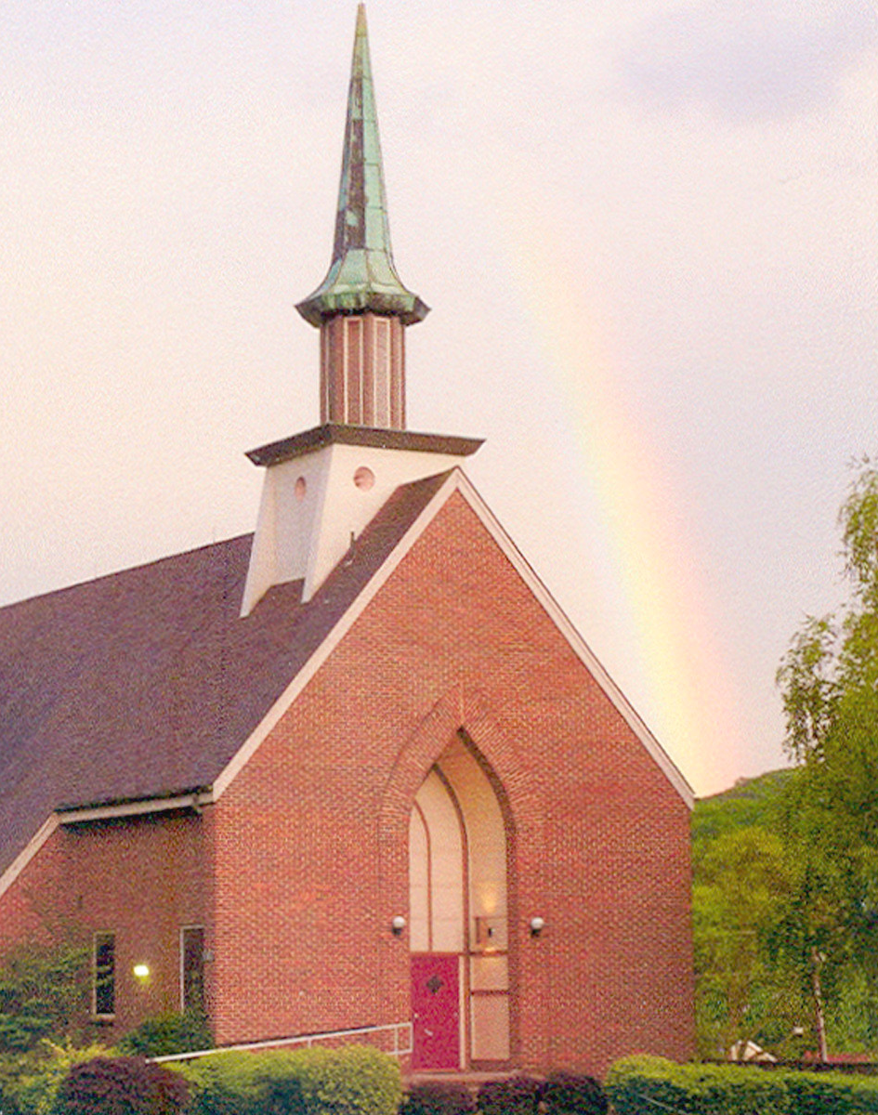
May 31, 2020 ~:~ Vol. 71 – No. 57

9:30am Adult Sunday School Class in the Pavilion
10:30am Worship (Drive-In Church, and Live streaming on Facebook)
Welcome/Call to Worship Jared Morgan
Worship in Song Kurt, Kim & Betty Helmick
Lord Jesus, I Long to be Perfectly Red Hymnal 583
Help Me to be Holy Red Hymnal 580
Guide My Feet Blue Hymnal 546
Announcements, sharing, and congregational prayer.
Scripture Luke 13:1-9 NIV
Message Pastor Duane
“The Importance of Bearing Fruit”
Song Healing Rain
Benediction

The ban on gatherings has been lifted allowing 50% occupancy, but we, your leadership team, have agreed to continue to hold the services outside. We will announce any change to our services by Friday evening via email, FaceBook and prayer chain. Please be in prayer for wisdom as we move forward.
Prayer Requests: please call Pastor Duane with any prayer request that you want to share, remembering that anything we stream on Facebook can be seen by anyone.
Remember to pray for our congregation on Wednesday mornings during the 6:00-9:00am time slot.
Happy Fiftieth Anniversary Paul ♥ Jan
Church Giving: Please consider mailing your gifts and tithes to the churches address.
Kynslea Lambka, Amber Kerns 7-year-old daughter has requested prayer letters to God for her healing from Guillain-Barre Syndrome. Please pass them along to Pastor Duane. Personal notes can be sent to her at 2071 Graysons Gap Road, New Creek, WV 26743,
Linda Weese Rittenhouse died Thursday at her home under the care of hospice. As a young girl she attended our church until marriage to Philip Rittenhouse. Condolences can be sent to Philip Rittenhouse, 545 Delp Road, Souderton, PA 18964
MCC Donations: many of the annual fund raisers for MCC have been cancelled due to the Covid-19 pandemic. Personal gifts can be mailed to PO Box 500, Akron, PA 17501-0500 or thru their website donate@mcc.org
LMC Coronavirus Relief Fund was created to respond to the severe financial needs that some LMC congregations are experiencing. Creating this fund was intended to help LMC practice mutual care within our family of congregations. If you wish to give to this fund, please see details sent out to your email or contact Pastor Duane.
For Your Prayer Time, Please Remember
Maxine Reall (Allegany Nursing)
Bobby Taylor (Frostburg Village)
Louise Gilpin (Frostburg Village)
Jeff Morgan (Healing)
Ella, Kim Twigg’s Sister (Healing)
June McKenzie, Kim Twigg’s Mother (Nursing Home)
Tina Helmick (Recurring Medical Issue)

