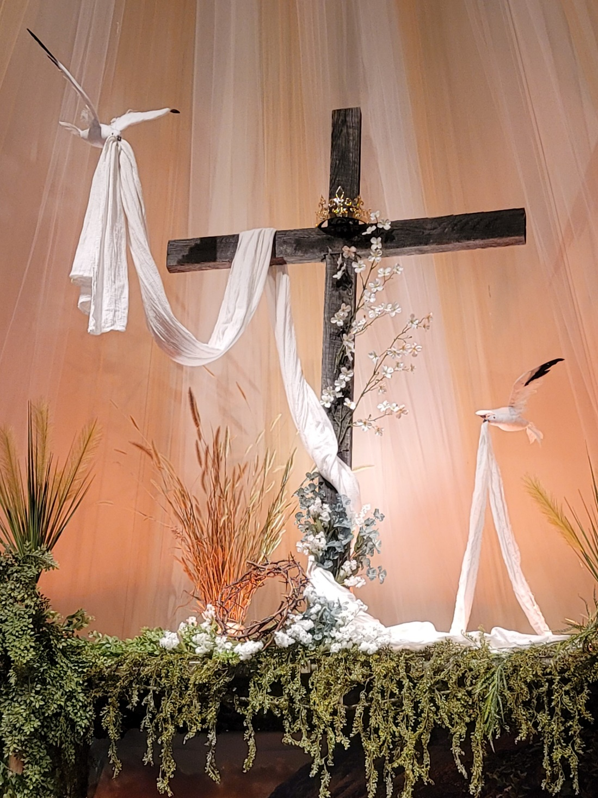
Looking Ahead
Next Sunday’s Message: by Pastor Duane
July 13th 7pm: Church Council
July 13th & 20th: World’s Attic
July 15th 6:30pm: Elder’s Meeting
July 18th10:30am: Worship in the Park

From Last Sunday:
Sunday School: 24 adults & 4 children/youth.
Worship: 32 attenders, with many live online viewers.

Birthdays This Week
Wayne Yoder 6
Caitlin Flowers Miller 7
Dezeray Fincham 9

Pastor Duane Frederick
Cell: 301.832.0406
Home: 301.387.2763
Email: revfrederick@hotmail.com
Bonnie cell: 301.832.0518
Elders
Paul Livengood: 304.788.1882
Dawn McFarland: 301.707.8129
Jared Morgan: 301.876.1537
Council Chairman
Kurt Helmick: 301.697.2979

Welcome to
Pinto Mennonite Church
13822 Pinto Rd SW, Cumberland, MD 21502
Pastor Duane Frederick
301.729.2714 pinto.church@gmail.com www.pintochurch.org
https://www.facebook.com/pintomennonitechurch

July 4, 2021 ~:~ Vol. 72 – No. 27

9:30am Adult Sunday School Class in the sanctuary
Children in the Fellowship Hall
10:30am Worship, Drive-In 88.7 FM, and Live streaming on Facebook)
Prelude Jan Livengood
Welcome/Call to Worship Jared Morgan
Worship in Song
Be Thou My Vision Blue Hymnal #545
Precious Lord, Take My Hand Blue Hymnal #575
Announcements, sharing, and congregational prayer.
Youth Time
Song: Children of the Heavenly Father B. Hymn. #616
Scripture John 1: 1 – 18 NLT
Message Paul Livengood
“A Childish Sermon”
Song: Guide My Feet Blue Hymnal #546
Benediction
Jay Dolly was moved to a Long-Term Acute Care at Morgantown WV Acuity Specialty Hospital which operates within Mon Health Medical Campus. Please continue to lift Jay, the family and health care workers up in your prayers. Mail can be sent to Paul “Jay” Dolly, Acuity Room 443, 1200 J D Anderson Dr, Morgantown, WV 26505
Remember to pray for our congregation on Wednesday mornings during the 6 to 9am time slot.
Elvin Sommers Memorial Fund: anyone wishing to contribute to OrrVilla Maple Terrace new wing in remembrance of our former pastor please make note in the memo line. We will receive donations for one more week. Thank you.
Bible School: The kids had a great week learning to trust God and about salvation through Jesus Christ. 39 Children attended and helped raise $1000 towards buying alpacas for families in Ecuador. A big THANK YOU to all the volunteers and parents who helped make this week a success.

Worship in the Park: Sunday, July 18th, we will be worshiping at the Rocky Gap Campground pavilion and amphitheater. Worship will start at 10:30 am, with a meal to follow. Chicken, paper products and bottled water will be provided. Bring side dishes and desserts. Turn right onto Pleasant Valley Road before entering the pay station at the park. Go approximately 1½ miles to the campground access on the left. You do not need to stop at the DNR station. A gate code will be required to enter the campground which will be given later. Turn left at the Camp Store and Beach Area sign (3rd left). Parking is limited so please carpool.
For Your Prayer Time, Please Remember
Jay Dolly (Healing)
Maxine Reall (The Shook Home)
Bobby Taylor (Frostburg Village)
Louise Gilpin (Frostburg Village)

