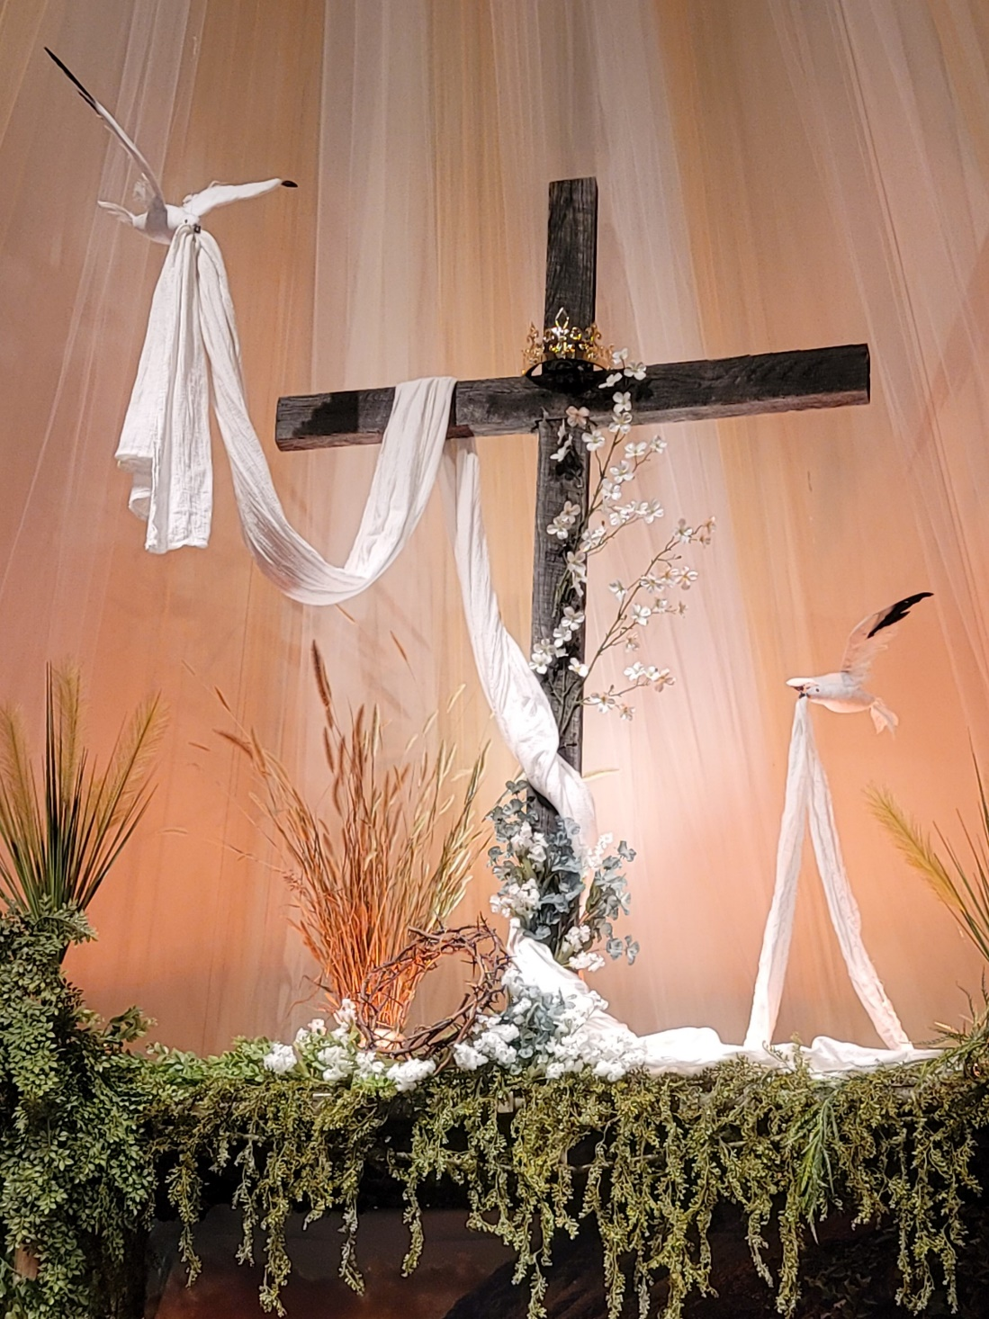
Looking Ahead
Next Sunday’s Message: by Paul Livengood
July 13th 7pm: Church Council
July 13th & 20th: World’s Attic
July 15th 6:30pm: Elder’s Meeting
July 18th: Worship in the Park 10:30am

From Last Sunday:
Sunday School: 24 adults & 8 children/youth.
Worship: 39 attenders, with many live online viewers.

Birthdays This Week Anniversarys This Week
Yvonne Hamilton 27 Phylip and Jessica Ohler 27
Garrett Dolly 29
Kevin Knight 29
Josh Morgan 30

Pastor Duane Frederick
Cell: 301.832.0406
Home: 301.387.2763
Email: revfrederick@hotmail.com
Bonnie cell: 301.832.0518
Elders
Paul Livengood: 304.788.1882
Dawn McFarland: 301.707.8129
Jared Morgan: 301.876.1537
Council Chairman
Kurt Helmick: 301.697.2979

Welcome to
Pinto Mennonite Church
13822 Pinto Rd SW, Cumberland, MD 21502
Pastor Duane Frederick
301.729.2714 pinto.church@gmail.com www.pintochurch.org
https://www.facebook.com/pintomennonitechurch

June 27, 2021 ~:~ Vol. 72 – No. 26

9:30am Adult Sunday School Class in the sanctuary
Children in the Fellowship Hall
10:30am Worship, Drive-In 88.7 FM, and Live streaming on Facebook)
Prelude Jan Livengood
Welcome/Call to Worship Terry Rotruck
Worship in Song
To God Be the Glory Life Songs #16
Count Your Blessings Life Songs #239
Announcements, sharing, and congregational prayer.
Youth Time
Song: You Are My All in All
Scripture Exodus 15:22-16:30 NIV
Message Pastor Duane
“Dealing With Discouragement”
Song: Battle Belongs
Benediction
Remember to pray for our congregation on Wednesday mornings during the 6 to 9am time slot.
Jay Dolly: remains an ICU patient at UPMC WMH awaiting transfer to a specialized care facility in Latrobe, PA. Please continue to lift Jay, the family and health care workers up in your prayers.

Elvin Sommers Memorial Fund: anyone wishing to contribute to OrrVilla Maple Terrace new wing in remembrance of our former pastor please make note in the memo line. We will receive donations for two more weeks. Thank you.
MCC Comforters: We would like to give special recognition to Betty Helmick for making over 100 comforters (knotted quilts) that have been donated to MCC for distribution throughout the world. These comforters have been a tremendous blessing to many people. Thank you, Betty, for all the time and love that you have put into ministering to others through these quilts!
Bible School: The kids had a great week learning to trust God and about salvation through Jesus Christ. 39 Children attended and helped raise $1000 towards buying alpacas for families in Ecuador. A big THANK YOU to all the volunteers and parents who helped make this week a success.
The Fredericks will be on vacation this week in Charlestown, SC with their family. They will be back on July 6th.

Operation Christmas Child: collection box is in the entry under the mailboxes for donations.
For Your Prayer Time, Please Remember
Jay Dolly (Healing)
Maxine Reall (The Shook Home)
Bobby Taylor (Frostburg Village)
Louise Gilpin (Frostburg Village)

